Disaster Recovery with IBM Cloud Virtual Servers

***Introduction***

*Incorporating automated recovery scripts and proactive monitoring is an essential part of disaster recovery planning in the world of IT and systems management. These strategies help organizations respond quickly and effectively to unforeseen disasters, minimizing downtime and data loss.*

Automated Recovery Scripts:

*Automated recovery scripts are preconfigured sets of instructions or code that are designed to automatically respond to and recover from specific IT system failures, issues, or disasters. These scripts play a crucial role in disaster recovery and business continuity planning by helping organizations quickly restore services and minimize downtime. Here are some key aspects of automated recovery scripts.*

1. Backup and Restore Automation:

* *Implement automated backup solutions that regularly create backups of critical data and systems. Create scripted procedures for restoring these backups quickly in the event of data loss or system failure.*

1. Disaster Recovery as Code (DRaC):

* *Treat disaster recovery processes as code by scripting the entire recovery process. Tools like Ansible, Puppet, or Terraform can be used to automate the setup of infrastructure and applications in a consistent and repeatable manner.*

1. Monitoring-Triggered Recovery:

* *Set up monitoring systems to detect signs of potential issues or disasters. When issues are detected, these systems can automatically trigger recovery scripts to restore affected services or systems.*

1. Failover and Redundancy:

* *For mission-critical systems, implement automated failover and redundancy mechanisms. Automated load balancers can route traffic to backup systems if the primary system fails, ensuring continuity.*

1. Cloud-Based Recovery:

* *Leverage cloud resources for disaster recovery. Cloud providers offer services like automated snapshots, automated scaling, and geo-replication, which can simplify recovery processes.*

1. Trigger Events:

* *Automated recovery scripts are typically triggered by specific events or conditions, such as hardware failures, software crashes, performance degradation, or security breaches. These trigger events are detected through monitoring systems.*

1. ***Testing and Validation:***

* *It’s essential to thoroughly test and validate recovery scripts to ensure their effectiveness. This may involve running simulations of disaster scenarios to confirm that the scripts can reliably recover systems.*

1. Documentation :

* *Comprehensive documentation of recovery scripts is critical. This documentation should include details on how the scripts work, how to configure them, and the expected outcome of the recovery process.*

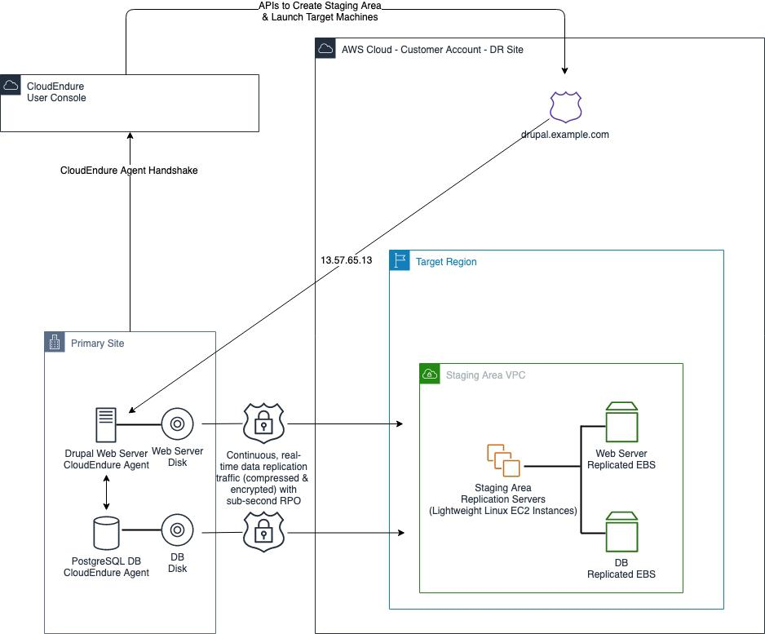

**IMAGE**

Proactive monitoring

*Proactive monitoring is a proactive approach to IT system management and maintenance that involves continuously monitoring and analyzing various aspects of an organization’s IT infrastructure, applications, and services to detect and address issues before they escalate into critical problems or cause downtime. Proactive monitoring aims to enhance system reliability, prevent service disruptions, and optimize performance. Here are key elements and practices associated monitoring.*

**Continuous Monitoring:**

* *Proactive monitoring involves the continuous and real-time observation of various IT components, including servers, networks, databases, applications, and security systems.*

Alerting and Notification:

* *Monitoring tools are configured to send alerts and notifications when predefined thresholds or conditions are met. Alerts can be sent to IT personnel through various communication channels, such as email, SMS, or pager.*

***Performance Metrics:***

* *Metrics related to system performance, resource utilization, response times, and error rates are collected and analyzed. Deviations from baseline metrics can trigger alerts.*

**Log Analysis:**

* *Logs generated by applications and systems are analyzed for anomalies, errors, and security incidents. Log analysis helps identify issues and potential threats.*

***Capacity Planning:*** *Capacity planning involves tracking resource usage trends and predicting when additional resources (e.g., CPU, memory, storage) will be needed to prevent performance degradation.*

***Security Monitoring****:*

* *Proactive monitoring includes security-related checks to identify*

*potential vulnerabilities, unauthorized access attempts, or abnormal behavior that may indicate a security breach.*

*Infrastructure Health Checks:*

* *Regular health checks are performed on network devices, servers, and storage systems to ensure they are functioning correctly. Failed hardware components can be replaced before they lead to system failures.*

*Predictive Analytics:*

* *Machine learning and predictive analytics are employed to identify patterns and trends in data that may indicate future issues or bottlenecks. Predictive analytics can provide insights into system*

*Automated Responses:*

* *In some cases, proactive monitoring systems are configured to take automated actions in response to alerts. For example, automatically restarting a service or reallocating resources to address*

*Documentation and Incident Response Plans:*

* *Proactive monitoring should be accompanied by clear documentation of monitoring configurations, alerting thresholds, and incident response plans. This ensures that IT teams can respond effectively when issues arise.*

*Regular Testing and Maintenance:*

* *Monitoring systems themselves need to be monitored and maintained. Regular updates and testing of monitoring tools and configurations are essential to ensure their reliability.*

***IMAGE***



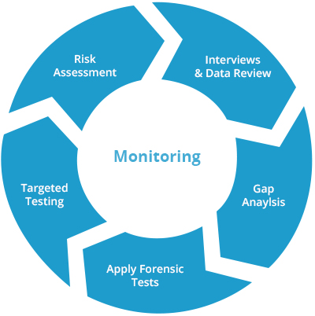***CHART***

***CONCLUSION***

***Automated recovery scripts are a critical component of disaster recovery planning and can significantly reduce the impact of unexpected disruptions on IT services and business operations. They enable organizations to respond quickly and effectively to ensure continuity and minimize downtime.***

***Proactive monitoring is a critical component of IT operations, as it helps organizations identify and address issues early, often preventing costly downtime and improving overall system reliability. It is a proactive strategy that complements reactive approaches, such as incident response, and contributes to the stability and availability of IT services.***